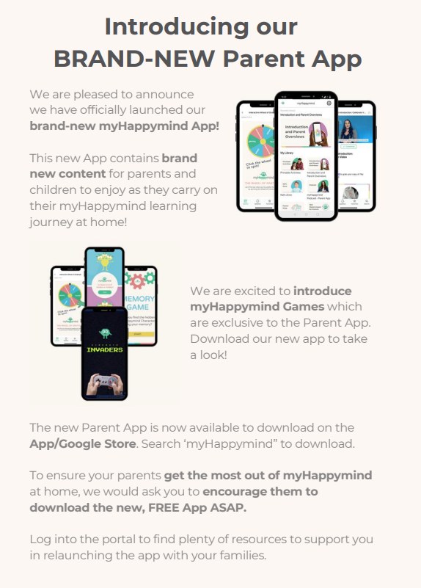

There is also the families programme, you may wish to look at if your interested.
Family Programme - myHappymind

