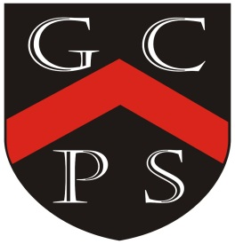

Goostrey Community Primary School
Music

Music is a universal language that embodies one of the highest forms of creativity. At Goostrey we hope our pupils will be engaged and inspired to develop a love of music and their talent as musicians, and so increase their self-confidence, creativity and sense of achievement.
EYFS and Key Stage 1 and 2
Aims throughout the Key stages for all children are to -
- perform, listen to, review and evaluate music across a range of historical periods, genres, style and traditions, including the work of great composers and musicians
- learn to sing and use their voices, to create and compose music on their own and with others, have the opportunity to learn a musical instrument and use technology appropriately.
- understand and explore how music is created, produced and communicated, including the inter-related dimensions: pitch, duration, dynamics, tempo, timbre, texture, structure and appropriate musical notations.
Guidelines for teaching music

The National Curriculum (2014) is used as a basis for curriculum planning, together with the Chris Quigley Essentials document. Reception through to Year 6 will all have access to the Love Music Trust scheme of work and the newly resourced Music Express Books for reference and vocabulary development. Year 5 music is delivered by the professional musicians from the Love Music Trust Wider opportunities scheme which will be complemented by class teaching where appropriate. We embrace all opportunities to develop music provision at school. Peripatetic teachers offer group of individual music lessons on a wide range of instruments and the Year 6 can access Play it Again subsidised music lessons following up from Wider Opps. Children are encouraged to perform on many occasions, at school and in the wider community. Mr and Mrs Hext, who are professional musicians for the Halle Orchestra also join us in school to complement the teaching and learning in Music.

When monitoring my subject I expect to see:
- National Curriculum Music/Chris Quigley Music Essentials taught
- Evidence that music is being taught:
Recordings of singing, composing, and performing
Photographs of concerts compositions and performances
Videos of concerts, compositions and performances
Evidence that music across a wide genre is being listened to, discussed and enjoyed, e.g. CDs or DVDs.
Children can talk about their music lessons and musical experiences
- At some time in the year classroom displays show some aspect of learning in Music, e.g. showing musical notation or themes or different composers
- Every child knows the name of our twin school in South Africa and knows they love to dance to a range of South African music!

